

**Resistance and Support in Stock curves**

horizontal line

# 

**Assignment 4**

Malireddi Sri Sai Shanmukh raj

Submission date: 29-10-23

# Support:

# Support is a price level at which a stock or market tends to find buying interest, preventing the price from falling further. It is like a "floor" that supports the price and acts as a barrier against further declines.

# Traders and investors often identify support levels as areas where they might consider buying the stock because historically, it has been a point where the stock found buying support and rebounded.

# Support levels can be based on historical price data, technical analysis, or fundamental factors. Common forms of support include trendlines, moving averages, or specific price points where the stock has previously bounced back from.

# Resistance:

# Resistance is a price level at which a stock or market tends to face selling pressure, preventing the price from rising further. It is like a "ceiling" that resists the price's upward movement.

# Traders and investors often identify resistance levels as areas where they might consider selling the stock because historically, it has been a point where the stock encountered selling pressure and reversed its upward trend.

# Resistance levels can also be determined through historical data, technical analysis, or fundamental factors. Common forms of resistance include trendlines, historical price peaks, or moving averages that have acted as barriers to further price increases.

# 

## TCS :

(Resistance and Support for TCS candlestick pattern in Intraday trade on 26-10-23.)

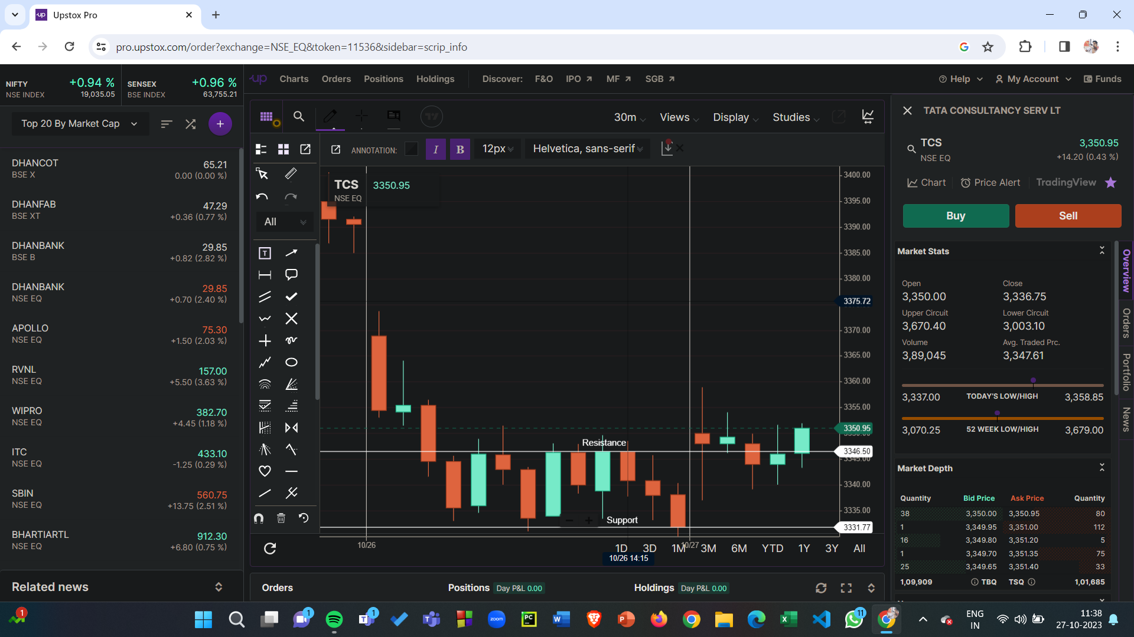

(Resistance and Support for TCS line pattern in Intraday trade on 26-10-23.)

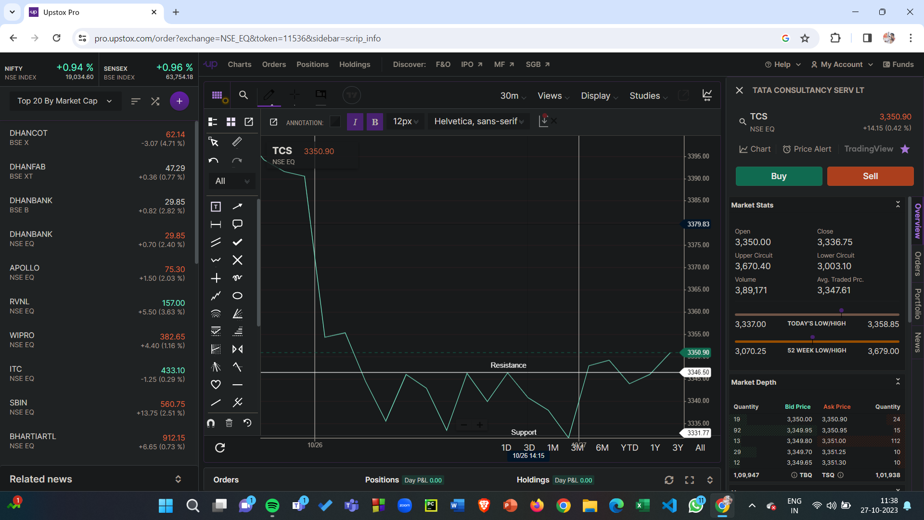

## Axis Bank :

Resistance and Support for Axis Bank in Intraday candle stick pattern on 26-10-23

## 

Resistance and Support for Axis Bank in Intraday line pattern on 26-10-23.

